


دانشکده مهندسی مکانیک
دانشگاه صنعتی امیرکبیر

درس LES
تمرین سری 4 (HM4)

دانشجو : بهراد عسگری (95126128)

استاد : دکتر امانی

Question 1 :

$$k$$ | $$Re({\hat{f}}_{k})$$ | $$Im({\hat{f}}_{k})$$ | $$\left|{\hat{f}}_{k}\right|$$
-8 | 0 | 0 | 0
-7 | 0.125 | -0.025 | 0.127
-6 | 0 | 0 | 0
-5 | 0.125 | -0.084 | 0.150
-4 | 0 | 0 | 0
-3 | 0.125 | -0.187 | 0.225
-2 | 0 | 0 | 0
-1 | 0.125 | -0.628 | 0.641
0 | 0 | 0 | 0
1 | 0.125 | -0.628 | 0.641
2 | 0 | 0 | 0
3 | 0.125 | -0.187 | 0.225
4 | 0 | 0 | 0
5 | 0.125 | -0.084 | 0.150
6 | 0 | 0 | 0
7 | 0.125 | -0.025 | 0.127

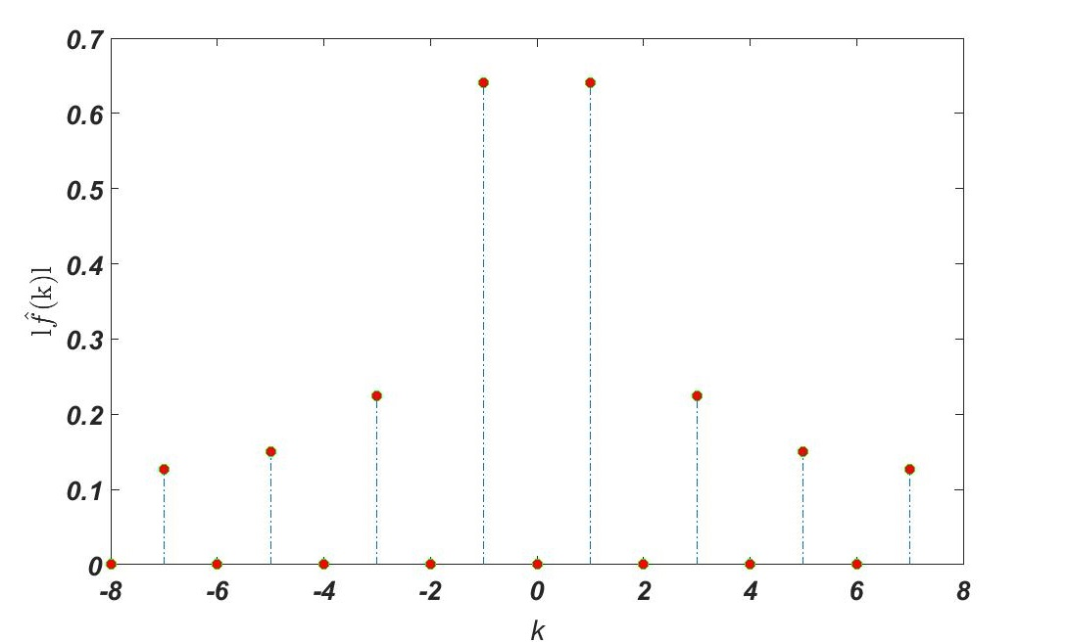
Figure 1 The magnitudes of the Fourier coefficients of the square function.

Code:
Code for figure 1

clear
clc

for i=1:1:16
if i<9
f(i) = 1;
else
f(i) = -1;
end
end

n=16;
A=fft(f)/n;
U=fftshift(A);
UU=abs(U);

for i=1:1:n
k(i)=-n/2+i-1;
end

stem(k,UU,'LineStyle','-.',...
'MarkerFaceColor','red',...
'MarkerEdgeColor','green')

xlabel('k')
ylabel('l$$\hat{f}$$(k)l','Interpreter','Latex')

Question 2 :
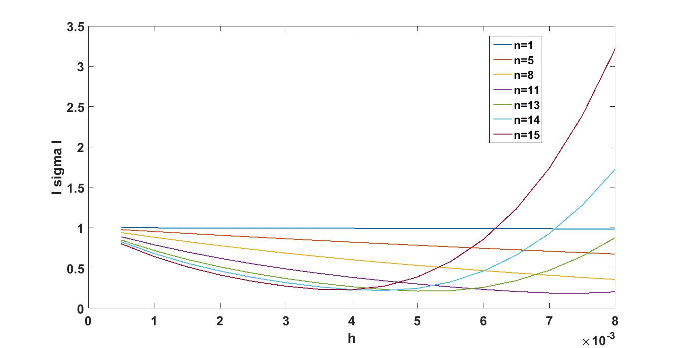
Figure 2 |σ| versus h for k = 2πn, n = 1, 5, 8, 11, 13, 14, 15.
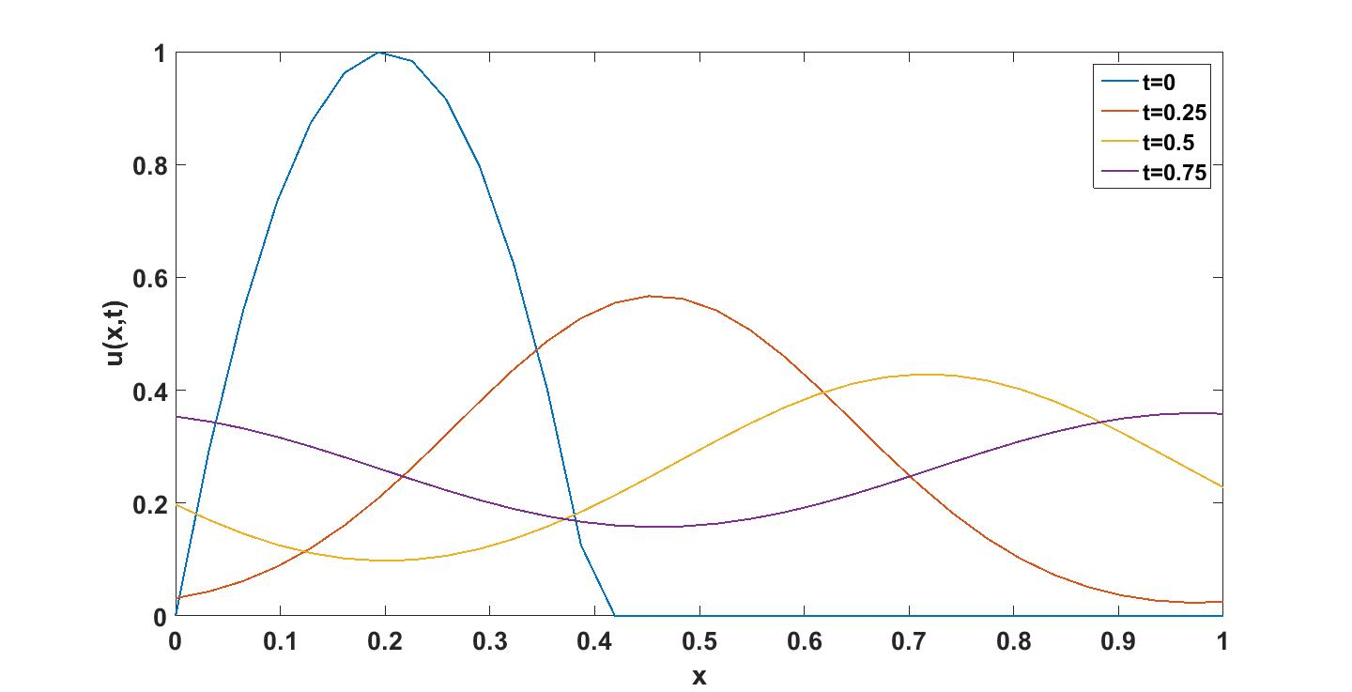
Figure 3 Numerical solution of the convective–diffusion equation.
Code:

Code for figure 2

clc
clear
N=32;
for b=1:1:N/2
h(b)=2*8e-3/N*(b);
j=2;
k(b)=2*pi*(j-1);
landa(b) = -(i*k(b)+0.05*k(b)^2);
sigma(b) = abs(1 + (landa(b)*h(b)) + ((landa(b)*h(b))^2)/2 + ((landa(b)*h(b))^3)/6 + ((landa(b)*h(b))^4)/24);

end
plot(h,sigma);
hold on;

for b=1:1:N/2
h(b)=2*8e-3/N*(b);
j=6;
k(b)=2*pi*(j-1);
landa(b) = -(i*k(b)+0.05*k(b)^2);
sigma(b) = abs(1 + (landa(b)*h(b)) + ((landa(b)*h(b))^2)/2 + ((landa(b)*h(b))^3)/6 + ((landa(b)*h(b))^4)/24);

end
plot(h,sigma);
hold on;

for b=1:1:N/2
h(b)=2*8e-3/N*(b);
j=9;
k(b)=2*pi*(j-1);
landa(b) = -(i*k(b)+0.05*k(b)^2);
sigma(b) = abs(1 + (landa(b)*h(b)) + ((landa(b)*h(b))^2)/2 + ((landa(b)*h(b))^3)/6 + ((landa(b)*h(b))^4)/24);

end
plot(h,sigma);
hold on;

for b=1:1:N/2
h(b)=2*8e-3/N*(b);
j=12;
k(b)=2*pi*(j-1);
landa(b) = -(i*k(b)+0.05*k(b)^2);
sigma(b) = abs(1 + (landa(b)*h(b)) + ((landa(b)*h(b))^2)/2 + ((landa(b)*h(b))^3)/6 + ((landa(b)*h(b))^4)/24);

end
plot(h,sigma);
hold on;

for b=1:1:N/2
h(b)=2*8e-3/N*(b);
j=14;
k(b)=2*pi*(j-1);
landa(b) = -(i*k(b)+0.05*k(b)^2);
sigma(b) = abs(1 + (landa(b)*h(b)) + ((landa(b)*h(b))^2)/2 + ((landa(b)*h(b))^3)/6 + ((landa(b)*h(b))^4)/24);

end
plot(h,sigma);
hold on;

for b=1:1:N/2
h(b)=2*8e-3/N*(b);
j=15;
k(b)=2*pi*(j-1);
landa(b) = -(i*k(b)+0.05*k(b)^2);
sigma(b) = abs(1 + (landa(b)*h(b)) + ((landa(b)*h(b))^2)/2 + ((landa(b)*h(b))^3)/6 + ((landa(b)*h(b))^4)/24);

end
plot(h,sigma);
hold on;

for b=1:1:N/2
h(b)=2*8e-3/N*(b);
j=16;
k(b)=2*pi*(j-1);
landa(b) = -(i*k(b)+0.05*k(b)^2);
sigma(b) = abs(1 + (landa(b)*h(b)) + ((landa(b)*h(b))^2)/2 + ((landa(b)*h(b))^3)/6 + ((landa(b)*h(b))^4)/24);

end
plot(h,sigma);
hold on;

xlabel('h')
ylabel('l sigma l')

Code for figure 3
clc
clear
N=32;
h=0.001;
for b=1:1:N
x(b)=1/31*(b-1);
end

for b=1:1:N
if x(b)<0.4
uu_0(b)=1-25*(x(b)-0.2)^2;
else
uu_0(b)=0;
end
end
u_0=fft(uu_0);
uf0 = ifft(u_0,N);

for b=1:1:N/2
k(b)=2*pi*(b-1);
landa(b) = -(i*k(b)+0.05*k(b)^2);
end
for b=N/2+1:1:N
k(b)=2*pi*(+b-N-1);
landa(b) = -(i*k(b)+0.05*k(b)^2);
end

for b = 1:1:N
uu1(b)=ode45(@(t,ut) landa(b).*ut,[0:h:0.25],u_0(b));
end

for b = 1:1:N
u1(b) = uu1(b).y(end);
end
u1(N/2+1)=0;
uf1 = ifft(u1);

for b = 1:1:N
uu2(b)=ode45(@(t,ut) landa(b).*ut,[0.25:h:0.5],u1(b));
end

for b = 1:1:N
u2(b) = uu2(b).y(end);
end
u2(N/2+1)=0;
uf2 = ifft(u2);

for b = 1:1:N
uu3(b)=ode45(@(t,ut) landa(b).*ut,[0.5:h:0.75],u2(b));
end

for b = 1:1:N
u3(b) = uu3(b).y(end);
end
u3(N/2+1)=0;
uf3 = ifft(u3);

plot(x,uf0);
hold on;
plot(x,uf1);
hold on;
plot(x,uf2);
hold on;
plot(x,uf3);
xlabel('x')
ylabel('u(x,t)')

